

**E-RECOVERY SYSTEM**

**SLN Internal System**

1. Introduction

E-Recovery system is a web based paperless system and it is provided facility to sent recoveries/allowances through the system with the authorization of relevant officer to Pay & Pension Department. System is given user friendly data entry screens to the users. Moreover it provides authentication facility, data validity checking, data availability, data integrity and tracking facility. In addition to that Users are no need to register to the system, they able to login to the system by using HRMS user name and password.

1. **User Login**

Select the User type before enter to the system.

User -For Data Entry

CMO/CDO -To Recommend

CO/HOD/AA -To Authorized

DDN(Pay) -To Approve

Subject Clerk - To Action

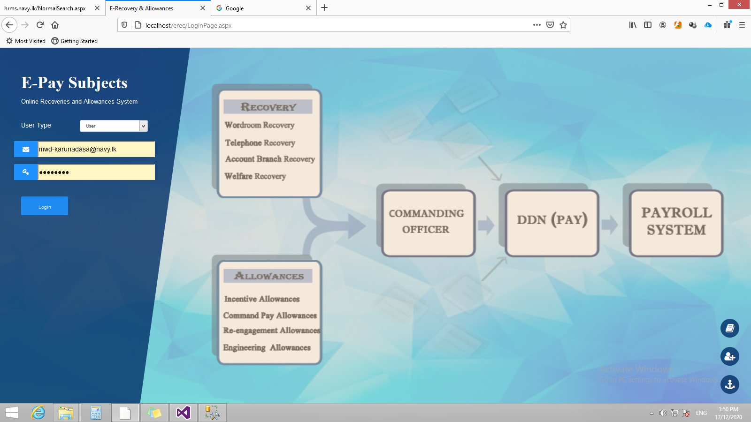

HRMS User name & Password

User Manual

Figure 1

1. **User**
   1. **Data Entry Page**

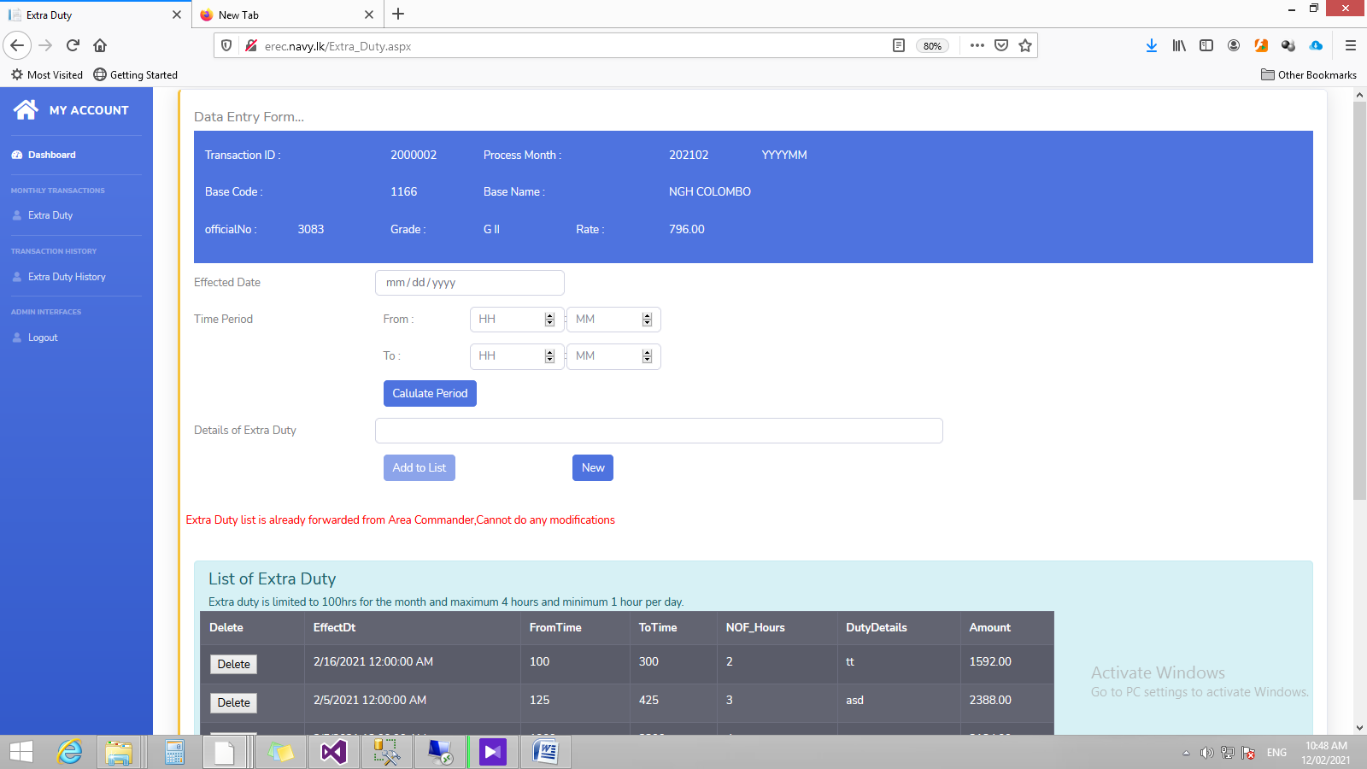

**1**

**2**

**3**

**4**

Figure 2

1st Step –Select the relevant date. That Effect date should be relevant to Pay Process Month and it is not be between your leave periods.

**1**

2nd Step –Feed the started time and finished time. You have to enter hours in 24 hr format and hour & minute should enter separately in given text box. Entered time period should not be between working hours further duration cannot be exceed 4 hrs.

**3**

**2**

3rd Step – Calculate Period will give validates your time period and calculates the extra duty hrs too.

4th Step – Add to List save extra duty details to system and load to List of Extra Duty Table.

**4**

Important: Extra Duty details should enter from the relevant medical /dental officer’s user account

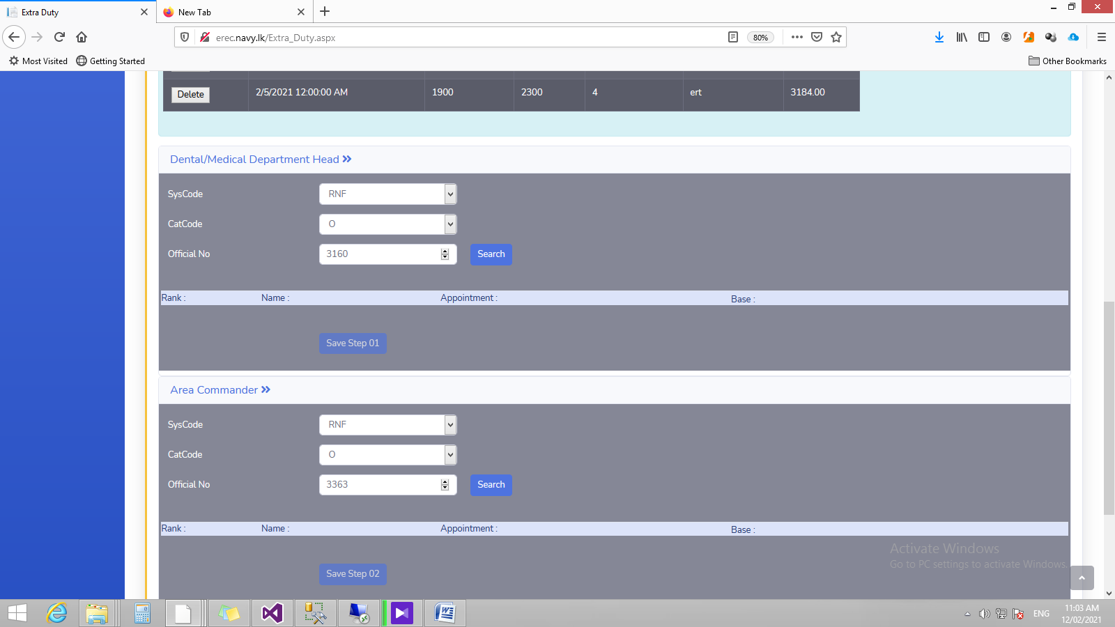

**5**

**6**

Figure 3

5th Step – once you completed the data entry, you should select your department head and click step 1 to update relevant details.

**6**

**5**

6th Step – Select your Area Commander and after that update the details by clicking Step 2.

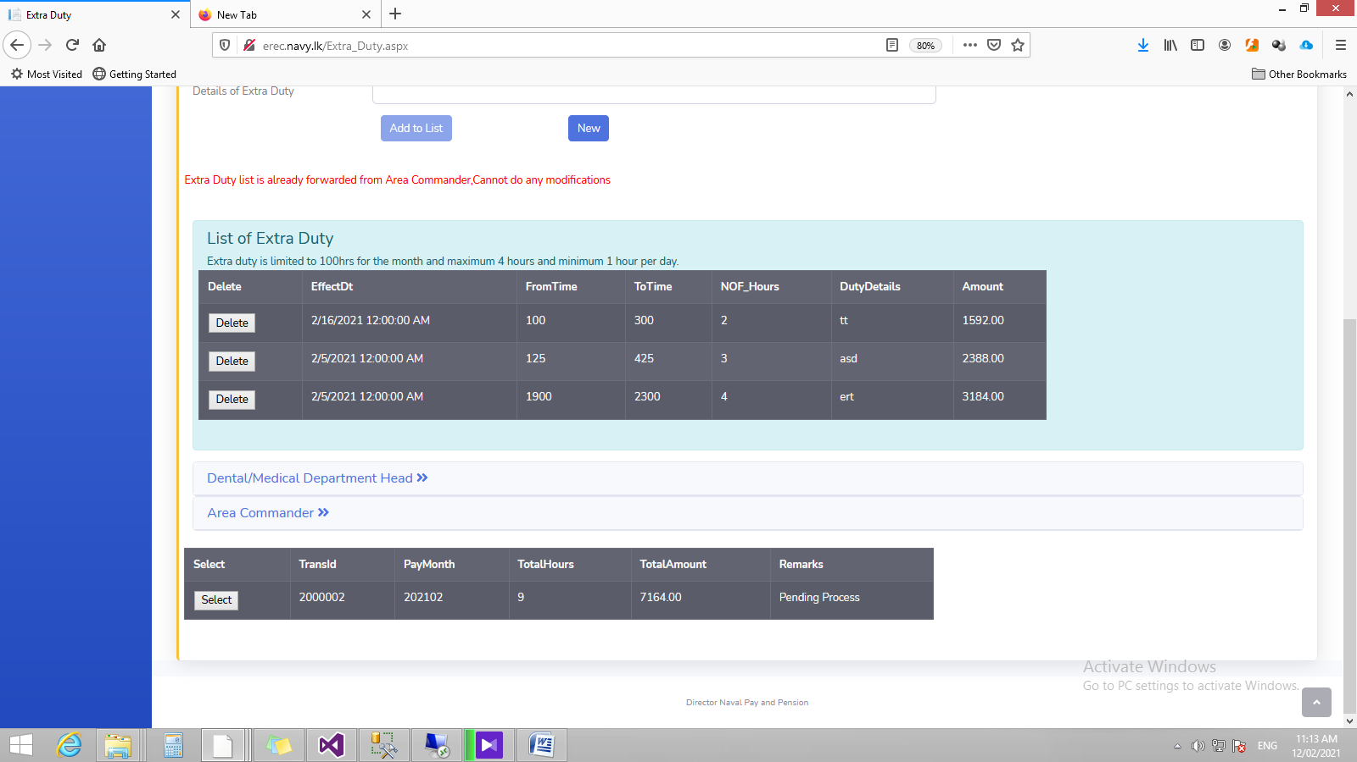

**7**

Figure 4

7th step – Once you update Department Head and Area Authority, it will forward to relevant authorized officers for next actions. System is given monitoring facility to user to trace the forwarded Extra Duty list.

**7**

* 1. **Extra Duty History**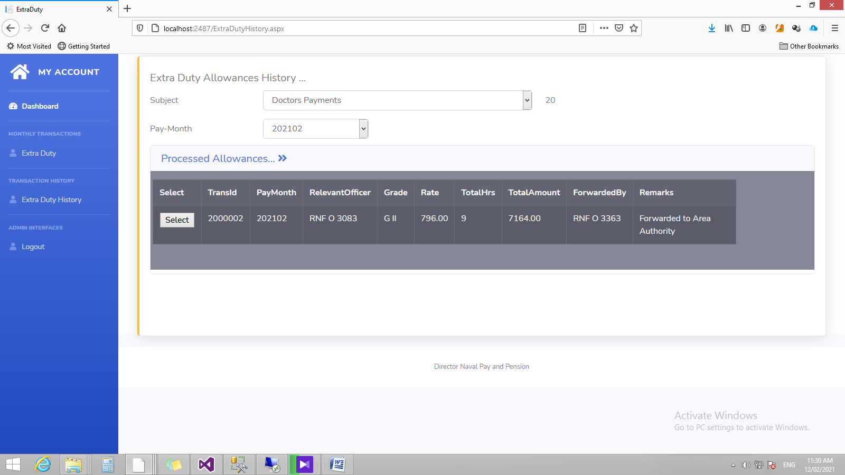

Figure 5

User able to view past Extra Duty list from Extra Duty History link. Relevant Subject and Pay Month Should select first and then it will load details to table. If required more details then you should click Button in the data table.

1. CMO/CDO
   1. Extra Duty Allowance

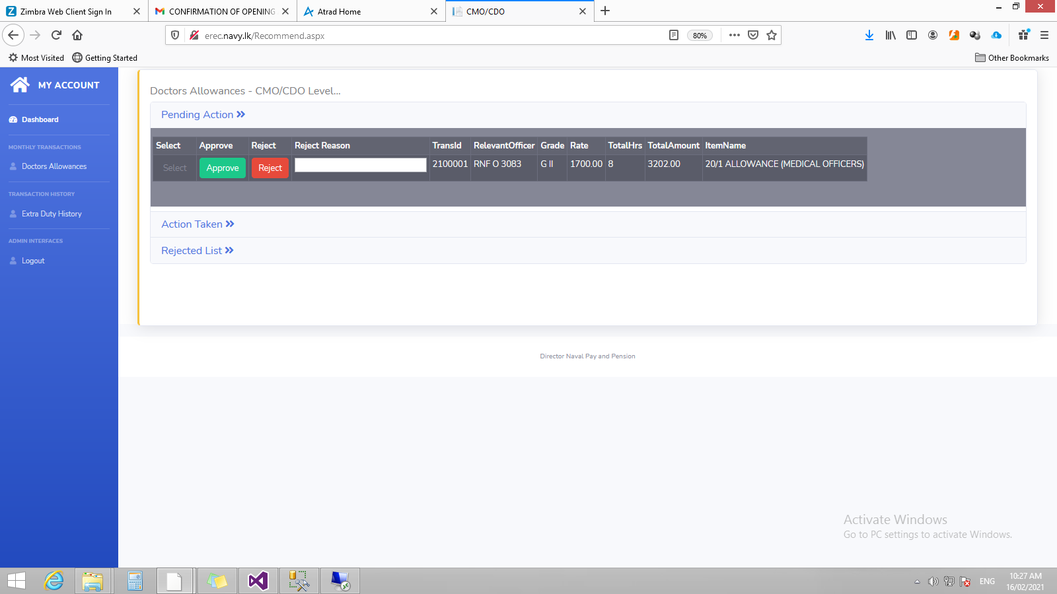

**2**

**1**

Figure 6

**1**

System provides facility to recommend or reject the received Extra duty lists. Further by clicking “select” button authorized person able to view all in details. Approved and Rejected transaction lists are displayed at Action Taken List and Rejected List.

User able to view past recommended Extra Duty list from Extra Duty History link. Relevant Subject and Pay Month Should select first and then it will load details to table.

**2**

1. Area Commander

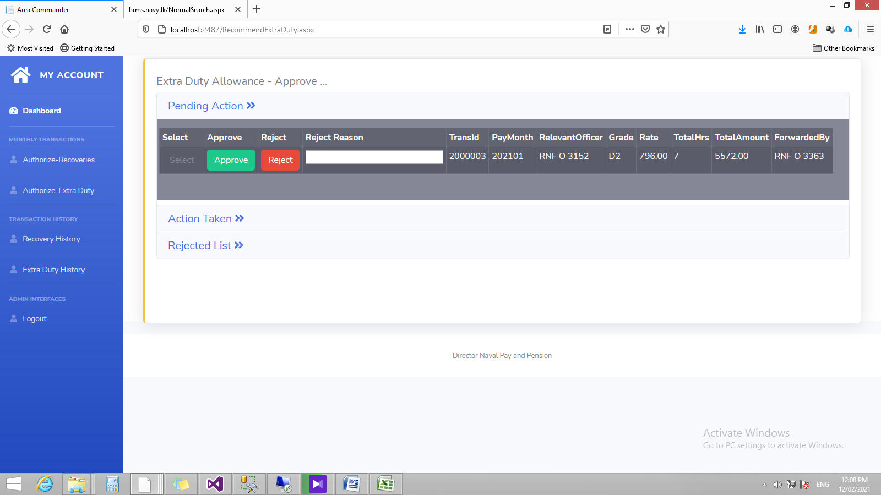

**2**

Figure 7

**1**

System provides facility to approve or reject the received Extra duty lists. Further by clicking “select” button authorized person able to view all in details. Approved and Rejected transaction lists are displayed at Action Taken List and Rejected List.

**2**

User able to view past recommended Extra Duty list from Extra Duty History link. Relevant Subject and Pay Month Should select first and then it will load details to table.